**Examining the Current use of Game-Based Learning Within   
Key Stage 3 History.**

Deanna R. Marshall

Contents

A Note on Game based learning. 2

Introduction 3

Literature Review 4

Historical Overview. 4

Are Games Educational? 4

Is GBL effective? 5

Examples of Research into GBL use with-in Education. 5

Examples of Research into GBL focusing on education in the UK. 6

Existing Examples of GBL in Schools Worldwide. 6

Existing Examples of GBL in UK primary and secondary schools. 6

Teacher’s perceptions to GBL. 7

Limitations to GBL in the UK. 8

The UK History Curriculum. 8

Performance metrics 8

Finance 8

UK Goverment 9

Conclusion. 9

Methodology 10

Limitations 10

Participants 10

Choice of Game. 10

Documentation. 11

Experiment design. 11

Findings and Analysis 11

Appendix 1 12

School KS3 History curriculums. 12

Department for Education KS3 History program of Study. 14

Appendix 2 19

History of the Mycenaean Civilization. 19

Blank Test paper. 21

# A Note on Game based learning.

Game-based learning (GBL) can cover various gaming formats, including (but not limited to) the following:

Analog Games like board games, card games, and outdoor games.

Digital Educational Games like *History Detectives* [BBC bitesize] or *Horrible Histories Raid and Trade* [Playerthree 2022] as well as serious games designed to educate students in areas like healthcare or climate change.

Video Games like *Minecraft* [Mojang Studios 2011] or *Kerbal Space Program* [Private Division 2015], that can be used in educational settings to help students learn academic content.

Game Design Projects: Where students can create their own games, either individually or as part of a group project, aiding them in grasping academic content.

For the context of this project GBL will specifically referring to Digital Educational Games and Video Games.

# Introduction

In 1991 at my secondary school there were two old BBC microcomputers, being lucky enough to be allowed to use one meant getting the opportunity to play educational video games like *School fun 3* [Database Publications 1990] or *Frogger* [Konami 1981]. Although at home, many students had more advanced games on consoles like the Super Nintendo, the games at school were still considered a weekly highlight amidst the routine of textbooks and equation-filled overhead projections.

My mother was a support assistant in a local primary school she would use another BBC microcomputer to play a game called *Podd* [Acornsoft 1984] to teach young students verbs thus expanding their vocabulary and improve their spelling.

As a music teacher my farther would search the local newspapers looking for any second-hand Atari STs that were up for sale. The Atari could run *Cubase* [Steinberg 1989] an audio program that could teach older students how to make music digitally. He picked the Atari as it was cheaper than buying new 486 Pentium PCs as his school could not afford to buy then, could not even afford new Atari’s.

Even in the early 1990s schools were experimenting with GBL.

Over the 30-year time span from 1991 to 2023 a lot has changed, technology has advanced, games have improved both in size and scope, and access to personal computers (PCs) has become the normal. Schools to have changed gone is the overhead projector to be replaced with a digital one, the BBC micros are now PCs (or Apples), and the use of the internet is now commonplace.

The pedagogical approach to teaching has also evolved over time in response to social and educational developments. Shifting from the rigid and structured lectures of the early 20th century to a more diverse range of techniques like the use of documentary videos and school trips (Gillard *1998).* GBL is another method that teachers can use as a pedagogical approach to teaching history. By incorporating GBL into the curriculum it has the potential to improve and enhance students' learning experiences.

Within the UK’s educational framework, there are four Key Stages, KS1 (5-7 years old), KS2 (7-11 years old) KS3 (11-14 year olds) and KS4 (14-16 year olds). This paper will focus on KS3. The curriculum has been designed to cover years seven to nine. The Department for education (DfE) last updated it 2013 (Department for Education, 2013) During year nine students select their chosen subjects to focus on for their General Certificate of Secondary Education (GCSE). History is considered an English Baccalaureate (EBacc) subject along with English language and literature, maths, science, geography, and a language (Department for Education, 2016). 278,750 students picked history as a subject in 2022 (GOV.UK, n.d.). With 70.6% of students getting a 4-9 grade (equivalent to C-A* under the prior grading system) (ofqual, 2014) this was the lowest percentage of all subjects excluding English, Maths, and Science.

In 1986 the BBC on episode of The Learning Machine (genome.ch.bbc.co.uk, 1986) asked:

*“Why is So Much Educational Software So Lousy?  
Why it is so difficult for parents and teachers to find educational software that does something useful, or at the very least does what it's supposed to do?”*

Is this still the case? Considering the evolution in teaching methods over the last 30 years, from the way history is taught, the technology used, and the curriculum followed. Has the use of GBL changed? Or is it still an anomaly?

This paper will examine, the current use of GBL in history education within the UK and compare it with educational practices in other countries, this could provide valuable insights into the adoption and effectiveness of GBL.

It will additionally include a proposed experiment, which could be used in further research to test the hypothesis that GBL can improve a student’s knowledge of the subject matter, over traditional learning techniques. This proposed experiment will focus on a specific historical event to allow for a more controlled and manageable experiment than covering the entire KS3 History curriculum.

It is important to note that while this study will concentrate on KS3 history, its findings could potentially be applicable to other subjects as well.

# Literature Review

## Historical Overview.

Abt *(1986)* coined the term Serious Games in 1970 in his book Serious Games. However, a case could be made that Plato was the first person to consider the use of serious games in his book *Laws* (643 BC) He presents the argument that if a man wishes to excel in a specific pursuit, he should practice this pursuit from an early age including through play. Plato for example, says.

*“The man who is to make a good builder must play at building toy houses.”*

Through this Plato argued that serious games can contribute to skill development.

Flanagan (2013) discusses the historical use of "Alea Evangelii," also known as the game of the gospels, as a teaching tool by the church in 12th century England. This game was utilized to convey religious messages and teachings to the community.

In the 17th century John Amos Comenius (1592-1670) put forward his views on the role of games and play in learning. Hellerstedt & Mozelius (2019) observed that Comenius presented a theory on education in which he viewed games to be the ideal form of learning. He presented this theory in his work Schola Ludus (1654).

Abt (*1986 first published in 1970*) stated.

“*Games may be played seriously or casually. We are concerned with ‘Serious Games’ in the sense that these games have an explicit and carefully thought-out educational purpose and are not intended to be played primarily for amusement. This does not mean that serious games are not, or should not be, entertaining.”*

However, his primary focus was weather the use of games in an educational setting can address the motivational inadequacies found in American schools.

## Are Games Educational?

Games such as *Civilization VI* [Firaxis Games 2016]*, Victoria 3* [Paradox 2022]*, or Empire Total War* [Creative Assembly 2009]can be educational if used:

* In conjunction with the curriculum.
* Within the correct context ensuring that any elements that may have been left out, or are incorrect historically, are explored and examined, to give the students a fuller picture of the content.

There is, however, the argument that games can influence and teach young people negative traits that could encourage youth violence (ProCon.org, 2018) Bogost (2007) considers this. He examined *Grand theft auto III* [Rockstar Games 2001] observing.

*“A game like Grand Theft Auto might teach us something about criminality, which the player can then use to perpetrate real crimes. Such representations when ratcheted up through the successive positive reinforcement provided by an involved game like Grant Theft Auto, has been blamed for numerous social ills, from general dereliction to school shootings.”*

However, Przybylski & Weinstein (2019) concluded that there was no evidence that video game engagement is not associated with adolescents' aggressive behaviour.

It could be argued that all games can teach us something, be that something positive like puzzle solving in *Portal* [Valve 2007], or negative like the objectification of women, something that can be seen in multiple games. (Skowronski, Busching and Krahé, 2021). It is therefore important that games are examined in the correct context and as stated above that any failings within the games are explored and examined, to give the students a fuller picture of the content.

## Is GBL effective?

There have been numerous studies showing that games have the potential to be used as learning tools (Alamri, 2016; Bartle et al., 2010; Gee, 2007; McCall, 2011) With Gee (2007) establishing view that GBL is engaging and effective way to learn. There have also been numerous studies that show that GBL helps students develop skills and knowledge (Clark, Tanner-Smith, & Killingsworth, 2015; Jabbar & Felicia, 2015; Tsai & Tsai 2020).

## Examples of Research into GBL use with-in Education.

There has been plenty of research in the use of GBL to teach individual subjects. Oceja, Abián-Cubillo and Torres-Trimallez, (2022) conducted a systematic literature review attempting to identify educational projects where games have been used to teach geography and history in secondary education. They identified 78 projects that used games for teaching geography and/or history in secondary education. They also concluded that there was a lack of educational projects using commercial off-the-shelf games, besides all the scientific evidence available that highlighted its benefits.

Liu, Shaikh, & Gazizova (2020) demonstrated that GBL can be used with-in education to provide positive results. Their research showed that the number of students who gave correct answers to more than half of the questions was greater by 1.72 times in the study group, compared to control group (91.86% and 53.42%, respectively). Udjaja et al., (2022) explored using it to increase Japanese language learning, they concluded that it could speed up the learning process. Hwa (2018) provides another example of GBL in education they observed how the use of Digital GBLs within a Mathematics class improved primary school students’ mathematical ability in Malaysia.

The Massachusetts Institute of Technology runs a program called Scheller Teacher Education Program and the education arcade. (MIT Scheller Teacher Education Program, 2019) One of the projects that came from this was a game called *Revolution* (2004) this is a multi-player, American Revolution-themed role-playing game based on historical events in the town of colonial Williamsburg. Set in 1775, on the eve of violent revolt in the colony of Virginia, the game was designed to be played in a 45-minute classroom session in a networked environment giving the students an opportunity to experience the daily social, economic, and political lives of the town’s inhabitants. (MIT Scheller Teacher Education Program, 2021)

## Examples of Research into GBL focusing on education in the UK.

Numerous groups and studies have been devoted to the exploration of GBL. Among these initiatives, The University of Winchester administers a program named "The Middle Ages in Modern Games" (Winchester, n.d.). They state that:

*“Games about the Middle Ages are increasingly important in the classroom, within historical research, and in the wider world.”*

The program seeks to investigate the narratives of medieval-themed games and examine their historical accuracy. Additionally, it investigates the reasons behind the construction of these narratives, the motives for presenting historical events in a specific manner, and the consequent impact on both players and the contemporary society.

Perrotta et al. (2013) produced a report for the National Foundation for Educational research (NFER) investigating Game-based learning they concluded that GBL could strengthen learning outcomes in the classroom. *Computer Games use in an Educational System* (Pee 2011) is a PhD thesis that focuses on how a custom-made educational game can be used to teach climate change within geography classes. It should be noted that although Pee tested on two KS3 classes in the UK he also tested on a class in Malaysia. Pee concluded that the use of computer games in education can support students with their learning. He also observed that.

*“The design and the implementation of the GeoEmission game in the classroom promoted collaborative and cooperative learning among the students and with the teacher.”*

However, he also found that mini games could be a distraction, which could distract students from the main teaching materials.

Foy (2021) examined the design and development of an educational digital game, Tales of Iona. The game was designed to promote understanding of the ancient Scottish island of Iona in years 6 or 7 (10- to 11-year-olds) they concluded that the game did influence the participants knowledge of the history of the island through the way they interacted with the game.

## Existing Examples of GBL in Schools Worldwide.

TeacherGaming (TeacherGaming, n.d.) was an organisation that had worked with over 20,000 K12 (KS1 to KS4) worldwide providing then with copies of *Minecraft Education Edition* [Mojang Studios 2016] as well as a modified educational version of *Kerbal Space Program.* However as of 2021 the program has been shut down.

Minecraft Education (education.minecraft.net, n.d.) has as of October 2021 over, 35 million teachers and students using *Minecraft Education Edition* across 115 countries (Minecraft, 2021). It has over fifty pre prepared lesson plans covering a range of subjects like Python 101 a lesson that teaches the basics or the programming language Python or exploring the city of Florence in Italy.

The Ubisoft Play to Learn program (Ubisoft, n.d.) offers free access to four of their educational games this includes *Assassin’s Creed Discovery Tour: Ancient Egypt* [Ubisoft Montreal 2017, *Rabbids Coding* [Ubisoft 2019], *Valiant Hearts: The Great War* [Ubisoft 2014], and *Anno 1404: History Edition* [Ubisoft 2020]. Currently it appears to only be available in the Us and Canada.

## ***Existing Examples of GBL in*** ***UK primary and secondary schools***.

There are very few existing examples organisations working with schools to provide resources like games, training etc… that would allow the use of GBL within the UK primary and secondary schools.

Emile Education (Emile, 2019) provides a range of GBL resources to over 4,000 primary schools within the UK. The games focus on KS1 and KS2 English, and maths. Reviews from schools prise it for its ease of use, flexibility, and well as the educational results that are being produced. With one headteacher saying that in his school Year 6 spelling results improved from 5.7 to 10.2 in 3 months. Emile also claims that a study by the University of Manchester, shows a 24% increase of correct answers on the Multiplication Tables Check test over a four-month period across the 4,000 schools, however as this study was not published it can not be verified.

ukie (ukie.org.uk, n.d.) runs six programmes focusing including Digital Schoolhouse and ukie students. 2021 Digital Schoolhouse in partnership with Ubisoft. They provided 5,000 licences for all their current *Discovery Tour* (Ubisoft 2018 onwards) games, to 52 schools consisting of primary and secondary schools in the UK (digitalschoolhouse.org.uk). However, the 52 schools only represent 0.24% of all UK schools. (Currently over 21,000) (Gov.UK). There seems to be no further information of the outcome of this initiative.

Minecraft Education has lesson content that has been mapped to the UKs curriculum with their stated goals to increase student engagement, facilitate classroom collaboration, provide opportunities for creative exploration, and connect learning to tangible outcomes. The National Highways has a range of *Microsoft Education Edition g*ames that focus on Science, Technology, Engineering, and Mathematics (STEM). It uses them to help students get interested in an infrastructure career. One example of this is the A428 project where they provided Minecraft workshops to local schools (around the A428) (Highways, 2022). The Learning Machine/Prodigy partnered with Microsoft and London Grid in 2019 to provide 100 primary, secondary, and other schools across London. (The Learning Machine Ltd, 2019). However, as with the Digital Schoolhouses partnership with Ubisoft, there seems to be no further information of the outcome of this initiative.

Apple Inc also runs a program called Apple Distinguished Schools (Apple (United Kingdom), n.d.). A program where schools use apple products with apple apps to teach students. It is likely that there is some use of GBL apps.

Individual schools may have incorporated GBL with in their teaching framework. But given that there are over 21,000 schools within the UK it has not been possible to corroborate this.

## Teacher’s perceptions to GBL.

Overall, the view is mostly positive (Allsop, Yildirim, & Screpanti 2013; Huizenga et al., 2017). One contacted teacher commented.

*“Games interest students, especially digital ones as they are part the fabric of what they consider current and accessible as a form to socialize with peers. Digitally, students are well versed in how to operate these programs, and so the barrier to access is also removed for many of them. A key benefit of games and GBL would be to make low stakes recall and cognitive linking skills greater, while still avoiding the intensity of more traditional techniques and activities.”*

However, there is some negativity from teachers towards GBL (Alamri, 2016). With one teacher having the view that.

“*I'm not convinced that games are conducive to learning for a few reasons: 1. I'm concerned that the competition element of a game distracts from the learning. 2. There is a false narrative that games are 'fun', and traditional learning methods are not. A good story well told will always be engaging. 3. I doubt if games can match the complexity of analysis offered by a good book*.

Any further research would need to take into consideration both opposing views.

## Limitations to GBL in the UK.

It should also be noted that even if all teachers in the UK had a positive view to GBL and there was no opposition to it. It would not necessarily mean that it would be easy to roll out to all schools. There are many limitations and obstacles that could prevent this.

### The UK History Curriculum.

The Curriculums current structure was set out in 2010 (Gov.UK) and requires a lot of topics to be covered in a limited amount of time. It focuses on English history from 1066 onwards it is broken down into seven areas of study, with each school chousing what to cover from each area. *(Fig.1)* Appendix 1 shows two examples of school KS3 history curriculum plans, as well as the full UK KS3 History programme of study. GBL could be used as a goal to help teachers cover these topics, *Europa Universalis IV* [Paradox 2013] is an example of one game that could be used to do this. However overall, the curriculum may need to be modified to make it easier to incorporate GBL.

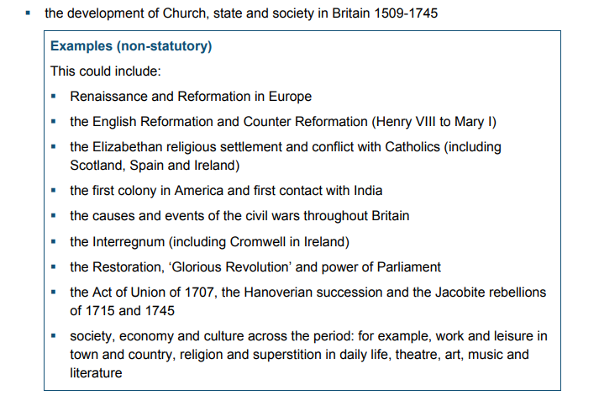

Figure : An area that a school must cover with some examples of what topics thay can focus on. (<https://assets.publishing.service.gov.uk/government/uploads/system/uploads/attachment_data/file/239075/SECONDARY_national_curriculum_-_History.pdf>)

### Performance metrics

Schools have a six-performance metrics that the government has laid out, four focus solely on GCSE results. (educationhub.blog.gov.uk,2022) There is a lot of pressure on schools and by extension the teachers to ensure that these metrics are as high as possible and thus ensuring that the school is high in the rankings. It is possible that schools may focus on ensuring that’s students are taught to pass there GCSEs and therefore keeping their performance metrics are high rather than being taught the subjects themselves. It may be that GBL is not conducive to this metric oriented teaching method.

### Finance

By far the largest obstacle is the financial state of individual schools. Many may not be able to afford to buy the required games, or the technology to use them. In 2023-24 the UK government has put aside £55.3bn for schools. *The National funding formulae for schools and high needs* (Gov.UK) lays out how the money is divided*.* The average per-pupil funding in schools for 2023-24 is £7,460 so for a school with 900 students would receive £ 6,174,000 however this has to be spent on everything from teacher’s wages to classroom materials, to running costs of the school and buildings. GLF Schools Annual Report and Financial Statements (GLF Schools (A Company Limited by Guarantee) Annual Report and Financial Statements, n.d.) demonstrate how many schools could struggle to operate on this amount with them as a whole operating on a loss if they just relied on the funding form the government. (*Fig.2)*

### UK Goverment

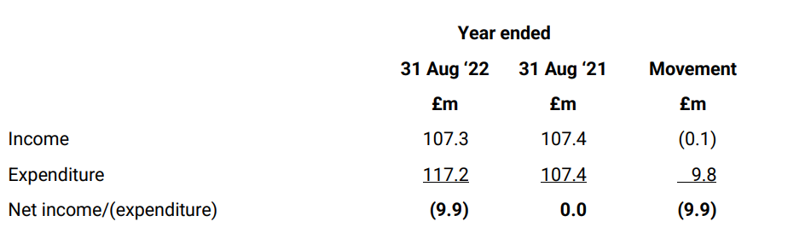

Figure : GLF's Summarised Financial Review. (<https://glfschools.s3.amazonaws.com/uploads/document/GLF-Schools-Accounts-2021-22.pdf?t=1675160471?ts=1687259882>) (pp14.)

In 2021 the UK government published *Research review series: history (GOV.UK, 2021)*.In it there no mention of GBL in any form, in fact their view into effective teaching in history sticks with the traditional way of teaching. Reading books, storytelling, and teaching for memory. However, teaching in this way is not a statutory requirement and schools are free to teach the subject in any way they like.

A petition was made in 2022 asking the government to Make Video Games a compulsory part of the national school curriculum, it gained 10,747 signatures, the DfE responded by saying:

*“The Department has no plans to introduce video games into the National Curriculum, which already provides pupils with a broad and enriching experience.”*

They went on to explain that the department was committed to evidence-based teaching, and they were not aware of any evidence that suggests video games are an effective tool for teaching a knowledge rich curriculum that is broad and balanced. (Petitions - UK Government and Parliament, n.d.)

There is also evidence that some members of the DfE do not believe that games are anything more than a gimmick with Tom Bennett OBE the Governments current behaviour czar saying 2016 that he believes that games like *Minecraft Education Edition* will get in the way of children learning, and that removing these gimmicky aspects of education is one of the biggest tasks facing us as teachers (Griffiths, 2016)

The lack of government support, combined with the other issues above could not only make it hard to implement GBL if a school wanted to, but actively discourage them to do so.

## Conclusion.

Research into GBL has tended to concentrate on higher education, with limited emphasis on secondary education within the UK education system. While some organizations such as NFER and Digital Schoolhouse provide some evidence of GBL in schools, the available data remains scarce, necessitating further investigation in this area.

This scarcity of research presents an opportunity for a more comprehensive and extensive study, not only focusing on GBL in History education but also encompassing a broader range of subjects and spanning a longer time period.

However, it is essential to acknowledge that although there is limited research specifically targeting the UK education system, a substantial body of research exists within the field, encompassing other subjects and diverse countries.

# Methodology

## Limitations

This experiment was designed with Key Stage 3 in mind. However, at the time of writing the feasibility of testing the hypothesis remains hindered by the closure of all schools for the summer holidays. In order to assess the suitability of the proposed experiment for its primary target demographic, a preliminary test was conducted utilizing the currently available extremely limited number of participants. The data gathered from this preliminary test is not of statistical significance. Nevertheless, the data acquired will allow for a more refined iteration of the experiment.

There is also the issue that any one or more of the participants could have knowledge of the subject matter or have played and experienced the chosen game. Both these could affect the results in this and any later tests.

The test subject matter is not part of any topic that would be covered in KS3 History, as it would normally be covered in Classical Civilization classes. However, due to time constraints, the fact that none of the participants were KS3 students, and the limited access to games it was decided that it was more important to ensure that the testing process as well as the test were sound, rather than ensuring that the subject matter covered a topic that is in the UK curriculum.

## Participants

Due to the unavailability of any KS3 students, the extremely limited number of participants that were available consisted of Game design Masters students from the University of Falmouth, as well as several lectures and technicians from the games department. All participants have a degree or higher level of education.

## Choice of Game.

Any game that could be used for the experiment would have to meet the following guidelines:

* Cover a historical period accurately.
* Take no more than twenty minutes to complete.
* Have a clear objective for the player to follow.
* Be able to access the game.
* Be easy to use.

Due time constraints, and ease of access only three games were considered. *Assassins Creed Origins* [Ubisoft Montreal 2017], *Assassins Creed Odyssey* (ACO) [Ubisoft Montreal 2018], and *Assassins Creed Valhalla* (ACV)[Ubisoft Montreal 2020]. All the above games have an educational version of them called the Discovery Tour. Ideally ACVs discovery tour would have been used as it covers the early medieval period, a topic that is covered in KS3. It also has been designed to be more interactive than the earlier discovery tours. However, due to the length of each quest it was not practical to be used in this instance. Because of this ACO was chosen. The tours with ACO are generally between ten to twenty-five minutes long. They are well laid out with clear guidelines to guide the participant. (TALK ABOUT THE USE OF HISTORIANS) However, it is less interactive than the later ACV discovery tour.

## Documentation.

(ADD SOMETHING HERE)

## Experiment design.

Using Quasi-experimental design, the experiment examined which pedagogical approach is potentially a better tool to improve a student’s knowledge of the subject matter GBL or a document covering the same topic. The participants were randomly designated either the game or the document. After answering several questions that established their current knowledge of the subject matter, and whether they had any prior knowledge of the game. The participants were given 20 minutes to read/play through the document/game. They were then given ten minutes to complete a test seeing how much they had learnt during the time they spent with the game/book. Appendix 2 includes both the document, and a blank copy of the test questions.

# Findings and Analysis

Even through the amount of data gathered from the small number of participants is not statically significant it has been included so a discussion can take place regarding the potential of this experiment in further studies ideally with its originally intended audience.

Chapter 5: Discussion

5.1 Comparison of Findings with Existing Literature

5.2 Implications for History Education

5.3 Recommendations for Educators

5.4 Areas for Further Research

Chapter 6: Conclusion

6.1 Summary of Findings

6.2 Contributions to the Field

6.3 Final Remarks

REFERANCES TO DO

Civ 6

Vitoria 3

Empire total war

*Assassins Creed Origins* [Ubisoft Montreal 2017], *Assassins Creed Odyssey* [Ubisoft Montreal 2018], and *Assassins Creed Valhalla* [Ubisoft Montreal 2020] *History Detectives* [BBC bitesize] or *Horrible Histories Raid and Trade* [Playerthree 2022] *Minecraft* [Mojang Studios 2011] or *Kerbal Space Program* [Private Division 2015], *Portal* [Valve 2007], *Grand theft auto III* [Rockstar Games 2001] *School fun 3* [Database Publications 1990] or *Frogger* [Konami 1981] *Cubase* [Steinberg 1989] *Podd* [Acornsoft 1984] *Europa Universalis IV* [Paradox 2013]

The Games For Change and IndieCade game festivals

. weThink is a platform that uses esports gaming to help students develop SEL and soft skills.

<https://www.mybib.com/#/projects/qxeW6o/citations>

<https://files.eric.ed.gov/fulltext/EJ1053979.pdf>

[**https://www.youtube.com/watch?v=8FBC496ggF0**](https://www.youtube.com/watch?v=8FBC496ggF0)

**what historians worked on assassin's creed odyssey**

[**https://archaeogaming.com/2019/04/19/consulting-for-ubisoft-on-assassins-creed-odyssey/**](https://archaeogaming.com/2019/04/19/consulting-for-ubisoft-on-assassins-creed-odyssey/)

**https://files.eric.ed.gov/fulltext/EJ1143830.pdf**

**https://link.springer.com/article/10.1007/s11528-023-00851-z**

funding for game based learning for gbl in the uk

<https://www.ubisoft.com/en-us/company/social-impact/local-involvement/articles/ubisoft-education#:~:text='Ubisoft%20Education'%20has%20designed%20programming,achieve%20their%20ambitions%20at%20university>.

<https://www.mcgill.ca/channels/channels/news/not-just-game-education-through-ubisoft-336594>

<https://www.studyinternational.com/news/assassins-creed-discovery-tour/>

<https://montreal.ubisoft.com/en/discovery-tour-ancient-greece-a-behind-the-scene-look-with-maxime-durand/>

<https://www.cbc.ca/news/canada/montreal/assassins-creed-discovery-tour-teaching-tool-1.4566553>

# Appendix 1

## School KS3 History curriculums.

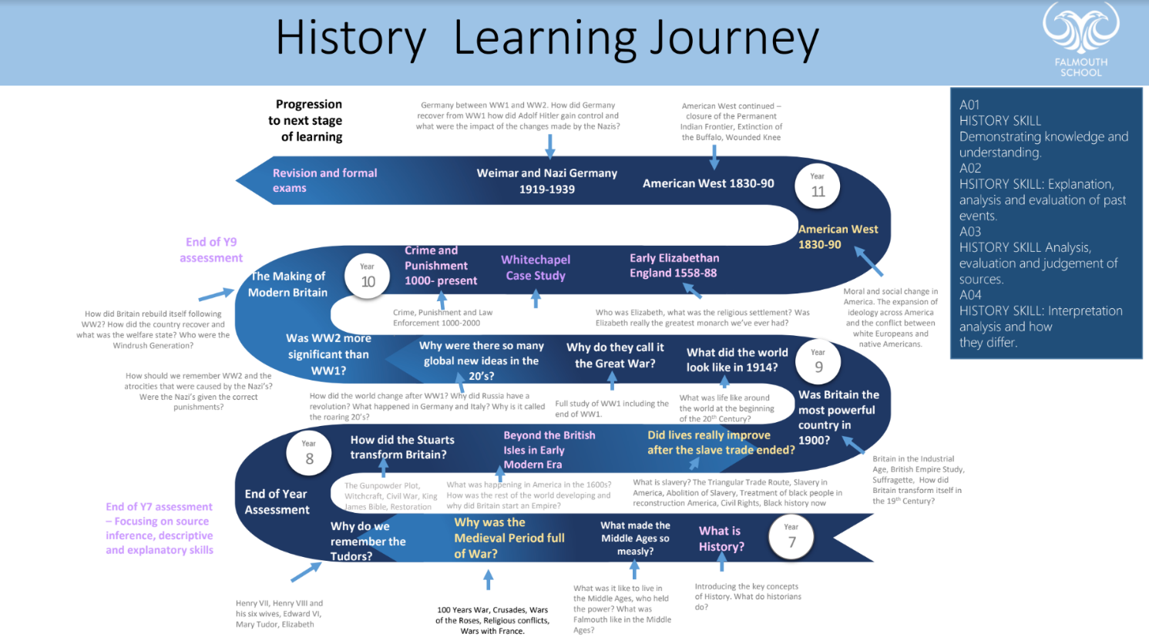

Figure : Falmouth Schools KS3 History curriculum. (<http://www.falmouth.cornwall.sch.uk/279/history>)

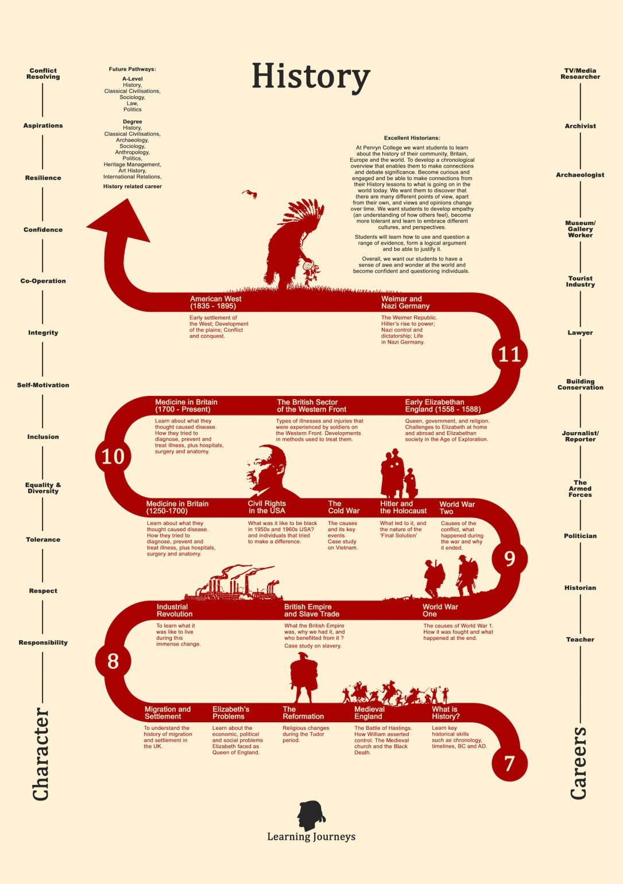

Figure : Penryn Colleges KS3 History curriculum. (<https://penryn-college.cornwall.sch.uk/subjects/ks3/history-re-ks3/>)

## A screenshot of a document Description automatically generatedDepartment for Education KS3 History program of Study.

# Appendix 2

## History of the Mycenaean Civilization.

**The Mycenaean Civilization.**

The Mycenaean Civilization flourished in the Late Bronze Age (c. 1600-1200 BCE), peaking from the 15th to the 13th century BCE. The Mycenaeans extended their influence throughout Greece and across the Aegean from Crete to the Cycladic islands. They are named after their chief city of Mycenae in the Argolid of the northeast Peloponnese.

The Mycenaeans were influenced by the earlier Minoan civilization (2000-1450 BCE) which had spread from its origins at Knossos, Crete to include the wider Aegean. Architecture, art and religious practices were assimilated and adapted to better express the perhaps more militaristic and austere Mycenaean culture. The Mycenaeans came to dominate most of mainland Greece and several islands, extending trade relations to other Bronze Age cultures in such places as Cyprus, the Levant, and Egypt. The culture made a lasting impression on later Greeks in the Archaic and Classical periods, most tangibly in their myths of Bronze Age heroes like Achilles and Odysseus and their exploits in the Trojan War.

**Mycenae.**

The largest city (although not a capital city in any sense) was Mycenae, built on an impressive citadel and hill over 278 metres (912 ft.) above sea level where there are remains of large 'palace' buildings, sections of the fortification walls and the famous Lion Gate (1250 BCE) with its heraldic pair of lions above the entrance. The heads of the animals were fashioned separately and are missing, but their necks are present. The pillar, specifically, is a Minoan-type column that is located on top of an altar-like platform upon which the lionesses rest their front feet.

Multiple shaft graves, including nine large stone tholos (circles) tombs (1600-1300 BCE) have also been found. Among the funerary gifts found were, full sets of weapons, ornate staffs, gold jewellery, as well as gold and silver cups. It has been estimated that one of the tombs contained about 15 kilos of gold in total.

The Treasury of Atreus is the largest and most elaborate of the known Mycenaean tholos tombs. It was decorated with bronze, and as with all tombs of the time its entrance door as well as the inside passageway been walled up.

German archaeologist Heinrich Schliemann, who discovered the famous grave circles in 1876, believed that he had found the body of the Mycenaean king Agamemnon, leader of the Achaeans in Homer's epic of the Trojan War, the Iliad, one of the artifacts he uncovered was a death mask that he famously clamed was the death mask of Agamemnon.

He is supposed to have told the king in a telegraph, "I have gazed upon the face of Agamemnon" however modern archaeological research suggests that the mask dates to about the 16th century BC, pre-dating the period of the legendary Trojan War by 300–400 years.

**Palaces.**

A large palace complex has been found at many of the Mycenaean centres. These complexes, whilst displaying some site-unique developments, display several important architectural features in common. The complexes were built around a large rectangular central hall or Megaron.

The Mycenaean Megaron was the precursor for the later Archaic and Classical temples of the Greek world and consisted of an entrance porch, a vestibule, and the hall itself. This was the heart of the palace and contained a large circular hearth. It was also the throne room of the ruler. Rooms were richly decorated with fresco paintings on the plaster walls and plaster-painted floors. Regarding materials, rooms in the palace were constructed with rubble fill and cross-beamed walls and then covered in plaster inside and limestone blocks outside. Columns and ceilings were usually of painted wood, sometimes with bronze additions.

**Demise**

The reasons for the demise of the Mycenaean civilization, which occurred in stages from c. 1230 BCE to c. 1100 BCE, are much debated. We do know that several sites were destroyed between 1250 and 1200 BCE. There is evidence of a different degree of destruction across sites, and some places escaped the chaos altogether. Some sites were then reinhabited but sometimes seemingly on a smaller scale and with less wealth than previously, while other sites became larger and more prosperous than ever. By around 1100 BCE, however, most Mycenaean sites had been reduced to mere villages.

Suggestions from scholars to explain the general collapse of the Mycenaean culture (and other contemporary ones in the Mediterranean) include earthquakes, internal social and political unrest, invasion from foreign tribes such as the Dorians, famine and drought or a combination of some or all these factors. With the mysterious end of the Mycenaean civilization and the so-called Bronze Age Collapse in the ancient Aegean and wider Mediterranean, there came the 'Dark Ages' (another extreme label for a period which was perhaps not as dark as all that) and, although some sites began to revive from the 10th century BCE, it would take several more centuries before Greek culture would finally regain the heights of the Late Bronze Age.

**Legacy.**

The Mycenaean civilization would so inspire the later Archaic and Classical Greeks from the 8th century BCE onwards that the Bronze Age period came to be seen as a golden one when people respected the gods, warriors were braver, and life was generally less complicated and more decent. Legendary names like Agamemnon, Menelaus, Achilles, and Odysseus - all Mycenaean Greeks - would be given immortal life in sculpture, on painted pottery and epic literature such as Homer's Iliad which told the story of the great Trojan War, very possibly a myth based on a real conflict or series of conflicts over the town of Wilusa between the Mycenaeans and Hittites.

*Sources: Wikipedia, World history encyclopaedia, The Classical World ISBN-13 978-0-141-02141-6, Eureka! ISBN 978-1-78239-516-4*

## Blank Test paper.

**Mycenaean Civilization.**

What Number did you pick?

**Multiple choice** – Highlight the correct answer (1 for each question)

**1. The Mycenaeans were...  
A** A civilization in Mesopotamia between  
 1575 and 1000 B.C.E. **B** A civilization in ancient Greece before  
 1600 B.C.E. **C** A civilization in Mesopotamia before  
 1575 B.C.E. **D** A civilization in ancient Greece  
 between 1600 and 1200 B.C.E.  
 **2. They were influenced by the earlier...  
A** Babylonian civilization. **B** Cycladic civilization. **C** Minoan civilization. **D** Egyptian civilization.  
 **3. What part of the Lion Gate is missing...  
A** The pillars. **B** The Lion Heads. **C** The outer walls. **D** The portcullis.  
 **4. Which archaeologist discovered the grave circles in 1876?  
A** Heinrich Schliemann. **B** Howard Carter. **C** Flinders Petrie. **D** John Lubboc Bart.

**5. How was the archaeologist incorrect about his findings?**

**A** He claimed he had found the Death mask of Agamemnon.

**B** He claimed he had found hundreds of graves.

**C** He claimed the graves were from the first Mycenaean dynasty.

**D** He claimed the graves were from an earlier civilization.

**6. How were Mycenaean houses decorated? A** They were not. **B** With painted plastered walls. **C** With brightly coloured tapestries.  
**D** With intricate stonework.

**7. What was the main hall or throne room called?   
A** Propylon. **B** Keep. **C** Megaron. **D** Pronaos.

**8. What town did the Hittites and Mycenaeans have a dispute over?   
A** Knossos. **B** Wilusa. **C** Athens. **D** Rome.

**9. How did the Mycenaeans bury and protect their dead?** (4)  
…………………………………………………………………………………………………  
…………………………………………………………………………………………………

**10. How were the later Greeks influenced by Mycenaean culture** (3)  
…………………………………………………………………………………………………  
…………………………………………………………………………………………………

**10. What were the 5 possible reasons for the Decline of the Mycenae civilization?** (5)

1)

2)

3)

4)

5)